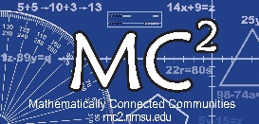
Structured Stationary: MC² Implementation Framework

What are my questions and wonderings as I consider supporting mathematics teaching for student learning every day?

 | Growth Mindset | Standards-Based Learning Environment (SBLE) | Launch/Explore/Summarize (Lesson Model) | Questioning & Discourse | Number Talks
WHAT IT IS

WHY IT MATTERS for student learning

