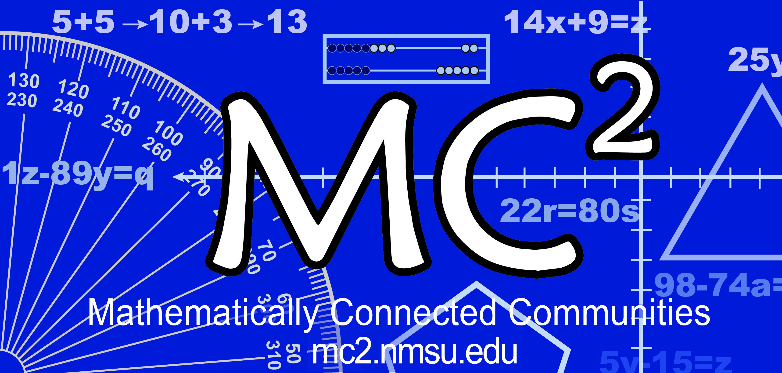
MC² Thinking Protocol
Data Collection & Analysis Tool

Date: Sample Date District: Sample District School: Sample Elementary School_

Grade: Kindergarten Teacher: Sample Teacher # Students: _____16__________
Standard(s) or Evidence Statement: K. NBT.A1 Compose and decompose numbers from 11 to 19 into ten ones and some further ones, e.g., by using objects or drawings, and record each composition or decomposition by a drawing or equation (such as 18 = 10 + 8); understand that these numbers are composed of ten ones and one, two, three, four, five, six, seven, eight, or nine ones.

Math Task: Show (Represent) 16 students in your class with a number and picture.

Enter number of students in the blanks below:
Think Individually:
16 students got the correct response. (All could represent 16 as the number of students in their class)

Think with a Partner:
students changed to the correct response.

Think with the Class:
students turned in the correct response.
students turned in the correct response with accurate computation.
students had the correct operation(s) but had a computation error.

Student Strategies Used to Solve Problem:
• Half of the students drew objects in a line.
• One student drew 16 tally marks and circled a group of ten and a group of six.
• One student drew a ten frame with small circles.
• Some drew such intricate, detailed pictures that they did not complete drawing 16 objects.

Student Strategies Used to Prove Answer was Correct:

Enter misconceptions observed and possible intervention needed to clarify each:
Misconception | Intervention
- Last number names the set. Students needed to recount (Table 8.1 p. 131)  - Tracking; counting each object only once; one–to–one correspondence  - Students who didn’t attempt to use ten frame need practice anchoring 5 and 10 (Van de Walle, p. 137, 138) | - Needs practice strengthening quantity to set. Practice counting a set between 5 & 10 using bags of objects at centers. Ask: How many? Can you say how many without counting again? Write the number.  - Ask: How do you keep track? Let’s double-check. Let’s touch each object and count. Teacher models “keeping track” with numbers 5-10.  - Five Frame Tell About, Figure 8.11, p. 138; Ten Frame Flash, p. 139; Teaching Channel Activity, Beyond Fingers 11-19, Make journals with scattered pictures. Ask students to circle 10 and write the number; Teaching Channel Quick Images

Comments:

