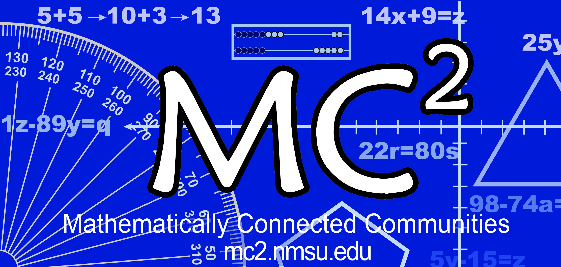
MC² Thinking Protocol
Data Collection & Analysis Tool

Date: District: School: _

Grade: Teacher: # Students: _______________
Standard(s) or Evidence Statement:

Enter number of students in the blanks below:
Think Alone:
students got the correct response.

Think with a Partner:
students changed to the correct response.

Think with the Class:
students turned in the correct response.
students turned in the correct response with accurate computation.
students had the correct operation(s) but had a computation error.

Student Strategies Used to Solve Problem:

Student Strategies Used to Prove Answer was Correct:

Enter misconceptions observed and possible intervention needed to clarify each:
Misconception | Intervention

Comments:

Note: This form is in WORD so it may be customized to suit your needs by adding, changing, and/or deleting sections.

