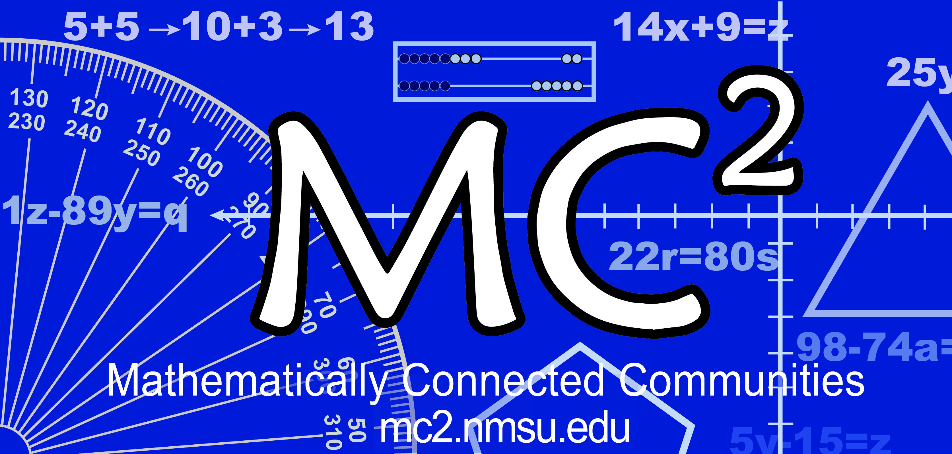
MC² Thinking Protocol
Data Collection & Analysis Tool

Date: Sample Date District: Sample District School: __Sample Elementary _

Grade: 5th Teacher: Sample Teacher # Students: _______24_________
Standard(s) or Evidence Statement: 5.NF.A.1
Use equivalent fractions as a strategy to add and subtract fractions: Add and subtract fractions with unlike denominators (including mixed numbers) by replacing given fractions with equivalent fractions in such a way as to produce an equivalent sum or difference of fractions with like denominators. For example, 2/3 + 5/4 = 8/12 + 15/12 = 23/12. (In general, a/b + c/d = (ad + bc)/bd.)

Enter number of students in the blanks below:
Think Alone:
8 students got the correct response.

Think with a Partner:
12 students changed to the correct response.

Think with the Class:
20 students turned in the correct response.
students turned in the correct response with accurate computation.
students had the correct operation(s) but had a computation error.

Student Strategies Used to Solve Problem:

Student Strategies Used to Prove Answer was Correct:
Fraction Bar Models; Algorithm

Enter misconceptions observed and possible intervention needed to clarify each:
Misconception | Intervention
- Choosing the right operation  - When comparing fractions, draw the same size whole  - Providing a model that accurately represents the fractions  - Connecting the fraction with the model and the operation | - Review differences in additive situations. When and why do you add or subtract? What operation is used to compare?  - Ask students to practice drawing fraction bars with same size wholes to compare fractional parts, Van de Walle, pgs. 295–296  - Ask students to prove their responses with a model of the situation. Emphasize keeping the whole the same size. Offer students different models for fraction concepts, Van de Walle, pgs. 290-296  - Ask students to use language–verbally and in writing–to connect the fraction to the operation and to the model

Comments:

