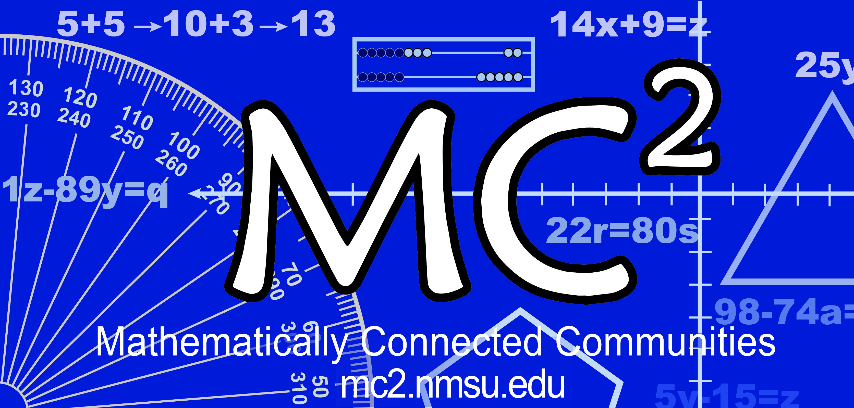
MC² Thinking Protocol
Data Collection & Analysis Tool

Date: Sample Date District: Sample District School: Sample Elementary _

Grade: 3rd Teacher: Sample Teacher # Students: _____20__________
Standard(s) or Evidence Statement: 3. Int. 2
Solve two-step word problems using the four operations requiring a substantial addition, subtraction, or multiplication step, drawing on knowledge and skills articulated in 3.NBT.

Enter number of students in the blanks below:
Think Individually:
3 students got the correct response in Part A.
5 students got the correct response in Part B.

Think with a Partner:
8 students changed to the correct response in Part A.
5 students changed to the correct response in Part B.

Think with the Class:
14 students turned in the correct response in Part A. in Part B.
11 students turned in the correct response with accurate computation in Part A. in Part B.
3 students had the correct operation(s) but had a computation error in Part A. in Part B.

Student Strategies Used to Solve Problem:

Student Strategies Used to Prove Answer was Correct:

Enter misconceptions observed and possible intervention needed to clarify each:
Misconception | Intervention
- Knowing when to add or subtract  - Making computation errors  - Making fair shares equally  - Knowing the difference between 6 groups of 6 items and 6 plus 6 | - More practice with problems with same structure as math task, part A; Keep the structure the same. Change the context and numbers.  - Practice precise calculations and double checking.  - Create more problems with same structure as math task, part B. Change the context and numbers. Allow students to use concrete models to show difference in groups with same number in each group and with addition.  - Use Model-based Problems, Van de Walle, pgs. 162-163

Comments:
Students are transitioning from additive to multiplicative reasoning. They just need practice using the Concrete– Connecting–Abstract sequence.

