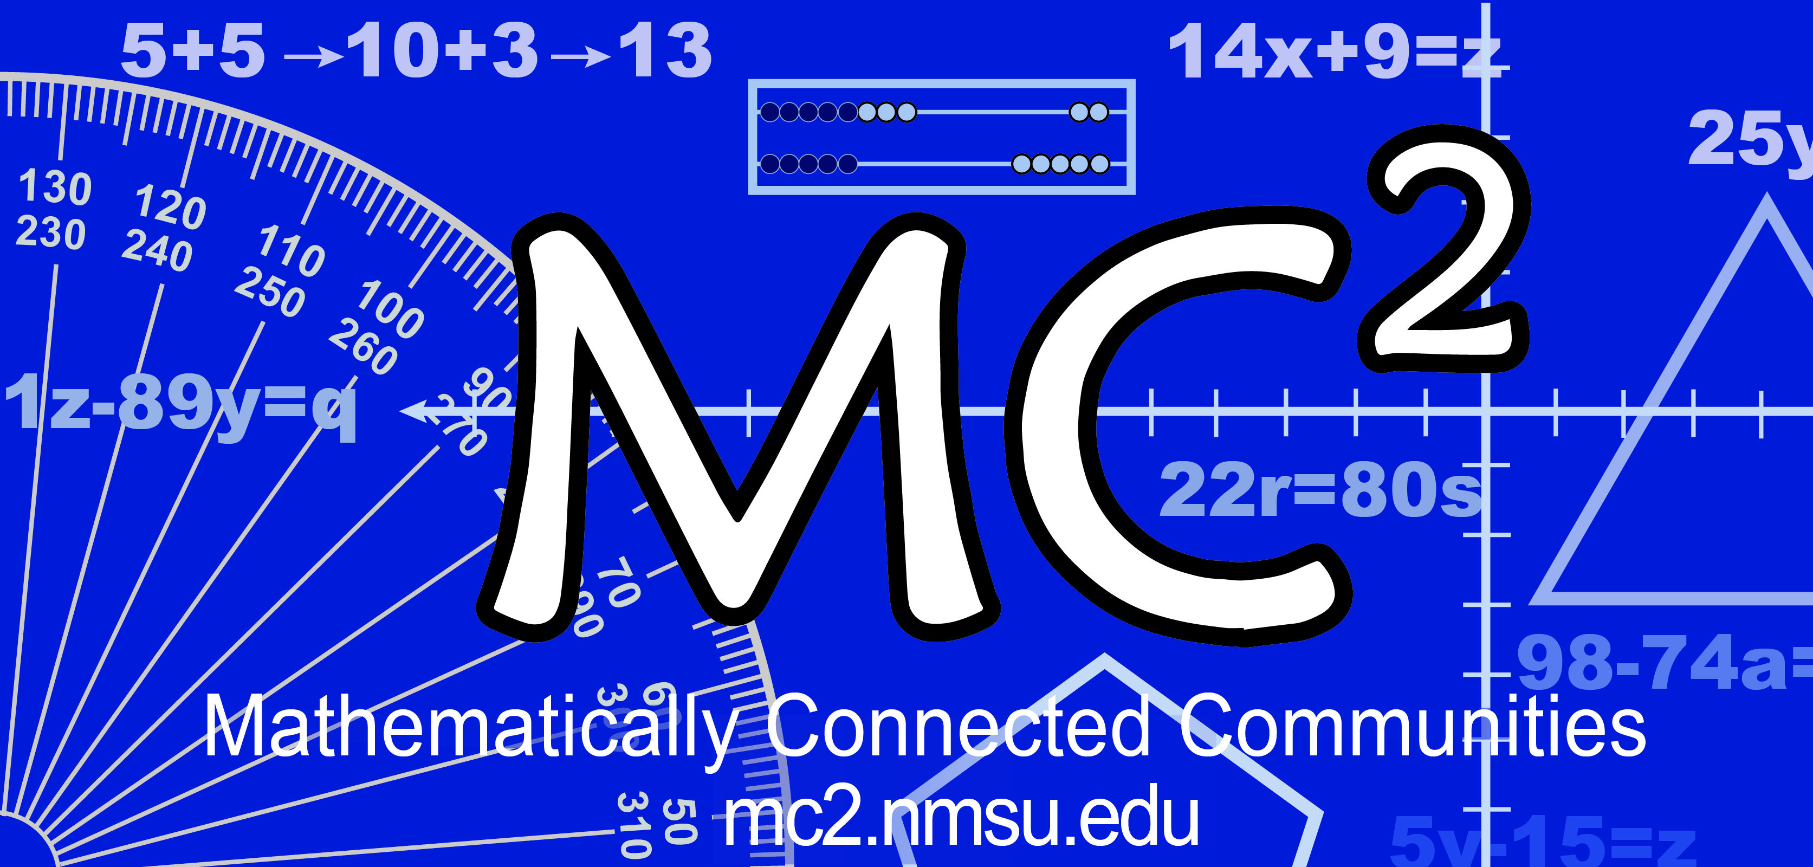
2017-2018 MC² Implementation Logic Model Template

Order of Planning
RESOURCES  Time, materials, people  When is our professional learning scheduled?  Who is responsible for organizing, scheduling,  and communicating? | PROCESSES/ACTIVITIES  Professional Learning  What needs to be in place to ensure our adult learning happens?  What additional structures or resources are needed to ensure our adult learning happens?  How do we purposefully plan for collegial support so that our adult learning happens?  (Joyce & Showers, 2002) | EDUCATOR LEARNING OUTCOMES  Changes in educator knowledge, skills, mindsets  What do we need to learn professionally that will support us in our implementation throughout the year? (Content/Math Practices/Pedagogy) | EDUCATOR PRACTICE OUTCOMES  Changes in educator practice  What do we want to implement from MathLabTM that will grow/develop our math teaching practice throughout the academic year?  How will this implementation support our hopes for student learning?  (Content/Math Practices/  Pedagogy) | INTENDED RESULTS FOR STUDENTS  Changes in student results  What hopes do we have for our students as math learners in the upcoming year?  What would it look like if students arrive at this place?
Insert in Step 6-Monitoring Implementation | Insert to Step 6-Monitoring Implementation | Insert in Step 3-Identify Focus Areas (MC² offers a strong professional learning menu) | Insert in Step 5-Create Desired Outcomes & Define Critical Actions | Insert in the beginning of Step 2-Analyze Data & Set Student Achievement Goals
Order of Implementation

