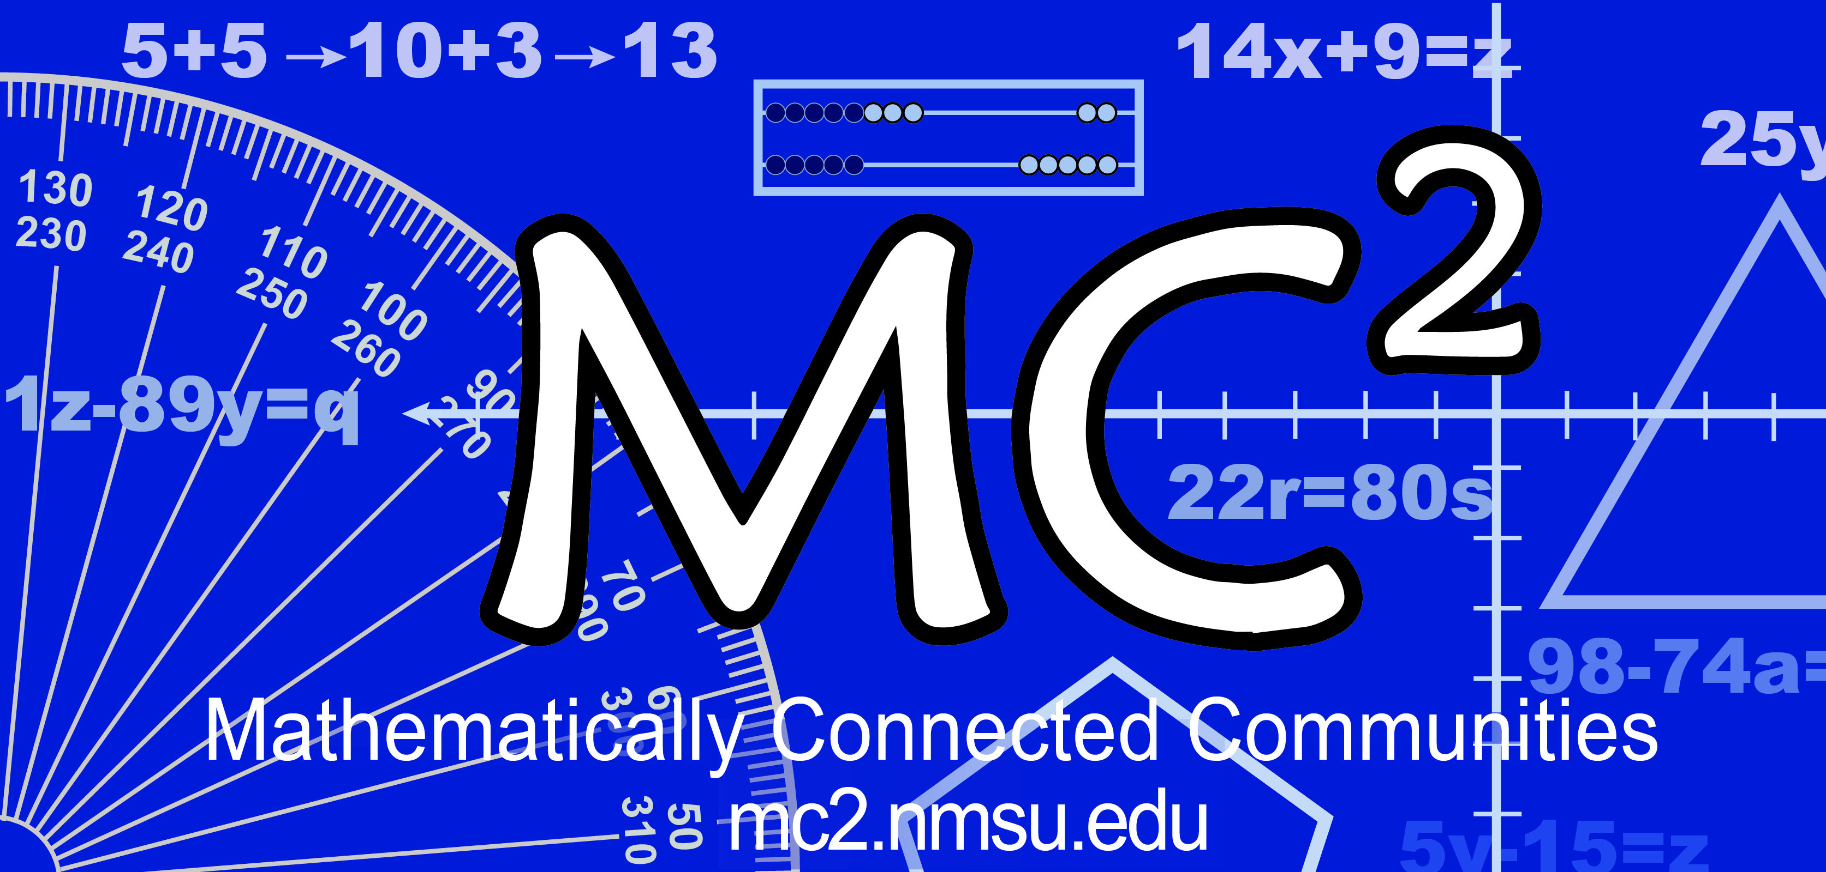
MC² Thinking Protocol
Student Reflection Form

Student: __Sample Name___________________________________________________________ Date: ____Sample Date

Reflect on the math task and respond to one or more of the following questions.

- What questions or wonderings do you have about the math?
- Were there any other strategies because my group all had the same one?
- How do you solve the problem in the first place?
- What to divide by?
- I was just wondering if my strategy was right.
- Are A and C the same?
- What did I struggle with?
I feel that 2/3 makes sense but not c/5. Am I supposed to multiply or divide? I need to work more on how to do proportions.

- What was my solution strategy? Did it work?
The problems we’re doing I recognize as proportions. The number of capfuls needs to be on the same side.

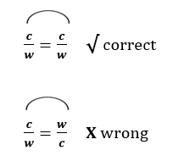
- What might I do different next time?
I just followed the numbers and that’s how I got my answer. He compared capfuls and capfuls and water and water. I want to change [my strategy] to that.

- What was easy when I had to work by myself?
Picking an answer since it was multiple choice

- What was hard when I had to work by myself?
To keep going and write about why I picked A as my answer

- What was easy when I had to work together?
Explaining the way I solved the problem

- What was hard when I had to work together?
To paraphrase what someone else said about what they were thinking

