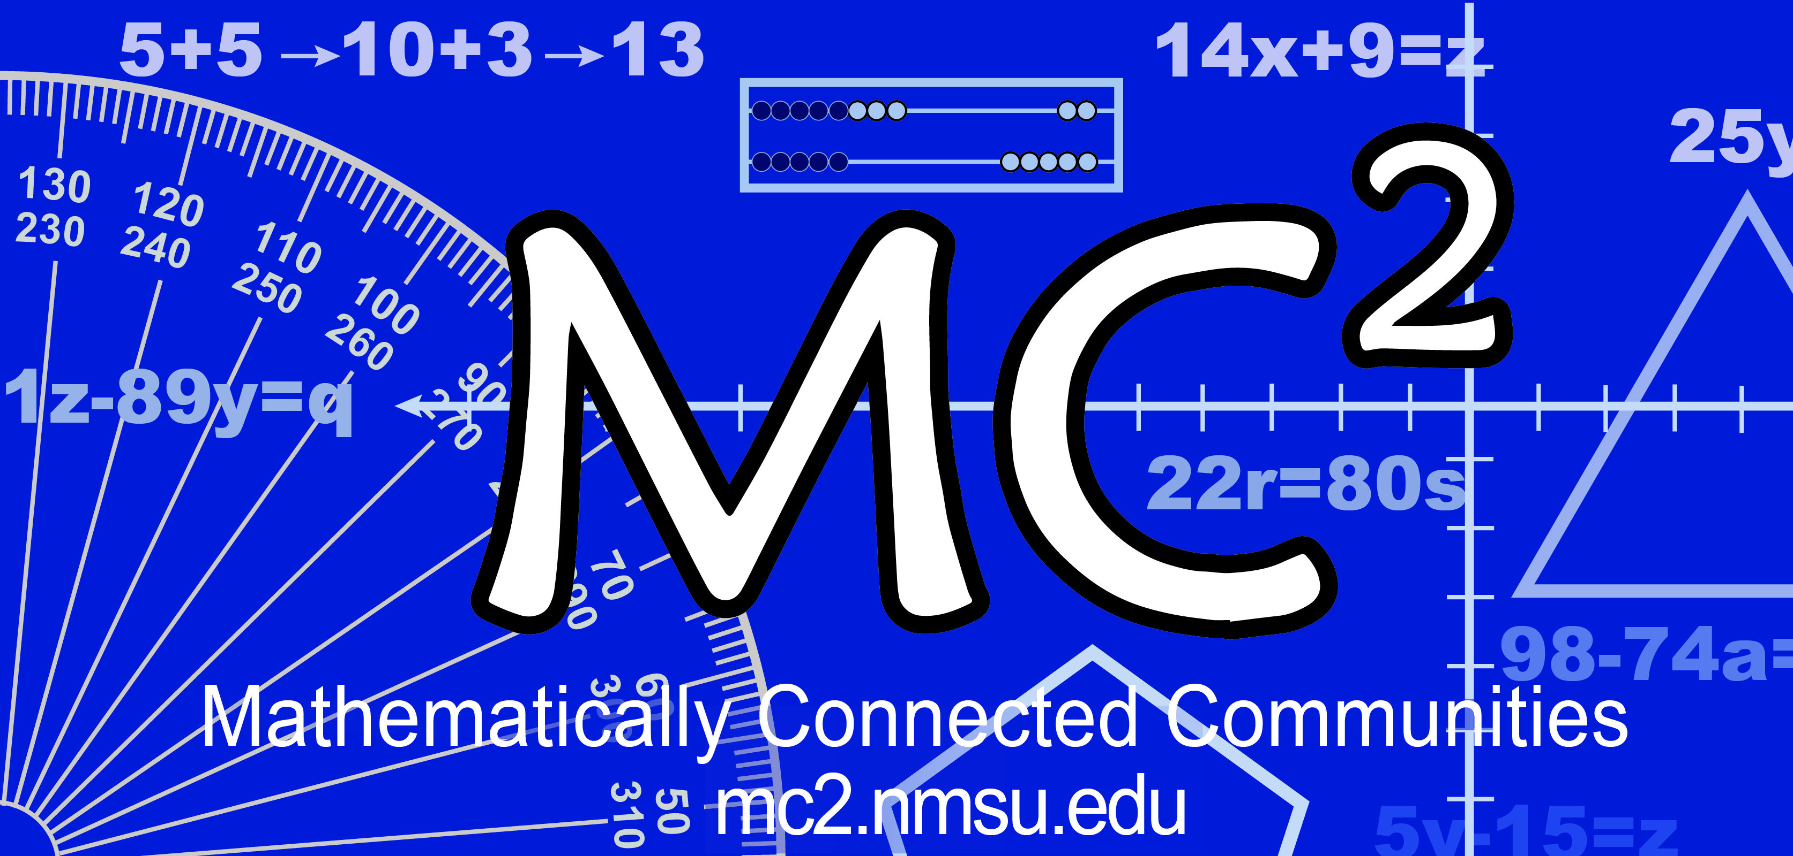
MC² Thinking Protocol
Data Collection & Analysis Tool

Date: Sample Date District: Sample District School: Sample Elementary

Grade: 5th Teacher: Sample Teacher # Students: _____20__________
Standard(s) or Evidence Statement: 5.NF.2
Solve word problems involving addition and subtraction of fractions referring to the same whole, including cases of unlike denominators, e.g., by using visual fraction models or equations to represent the problem. Use benchmark fractions and number sense of fractions to estimate mentally and assess the reasonableness of answers. For example, recognize an incorrect result 2/5 + 1/2 = 3/7, by observing that 3/7 < 1/2.

Enter number of students in the blanks below:
Think Alone:
4 students got the correct response.

Think with a Partner:
12 students changed to the correct response.

Think with the Class:
16 students turned in the correct response.
students turned in the correct response with accurate computation.
students had the correct operation(s) but had a computation error.

Student Strategies Used to Solve Problem:

Student Strategies Used to Prove Answer was Correct:
Algorithm; model shared from another fifth grade class

Enter misconceptions observed and possible intervention needed to clarify each:
Misconception | Intervention
- Choosing the right operation  - Meaning of numerator and denominator–some students added numerators and denominators without finding common denominator  - Providing a model that accurately represents the fractions  - Connecting the fraction with the model and the operation | - Review the differences in additive situations – when and why do you add or subtract? What operation is used to compare?  - Review meaning of numerator (counting number) and denominator (number of equal parts of the whole)  - Ask students to prove their responses with a model of the situation. Emphasize keeping the whole the same size. Offer students different models for fraction concepts, Van de Walle, pg. 290-296  - Ask students to use language - verbally and in writing – to connect the fraction to the operation to the model.

Comments:

