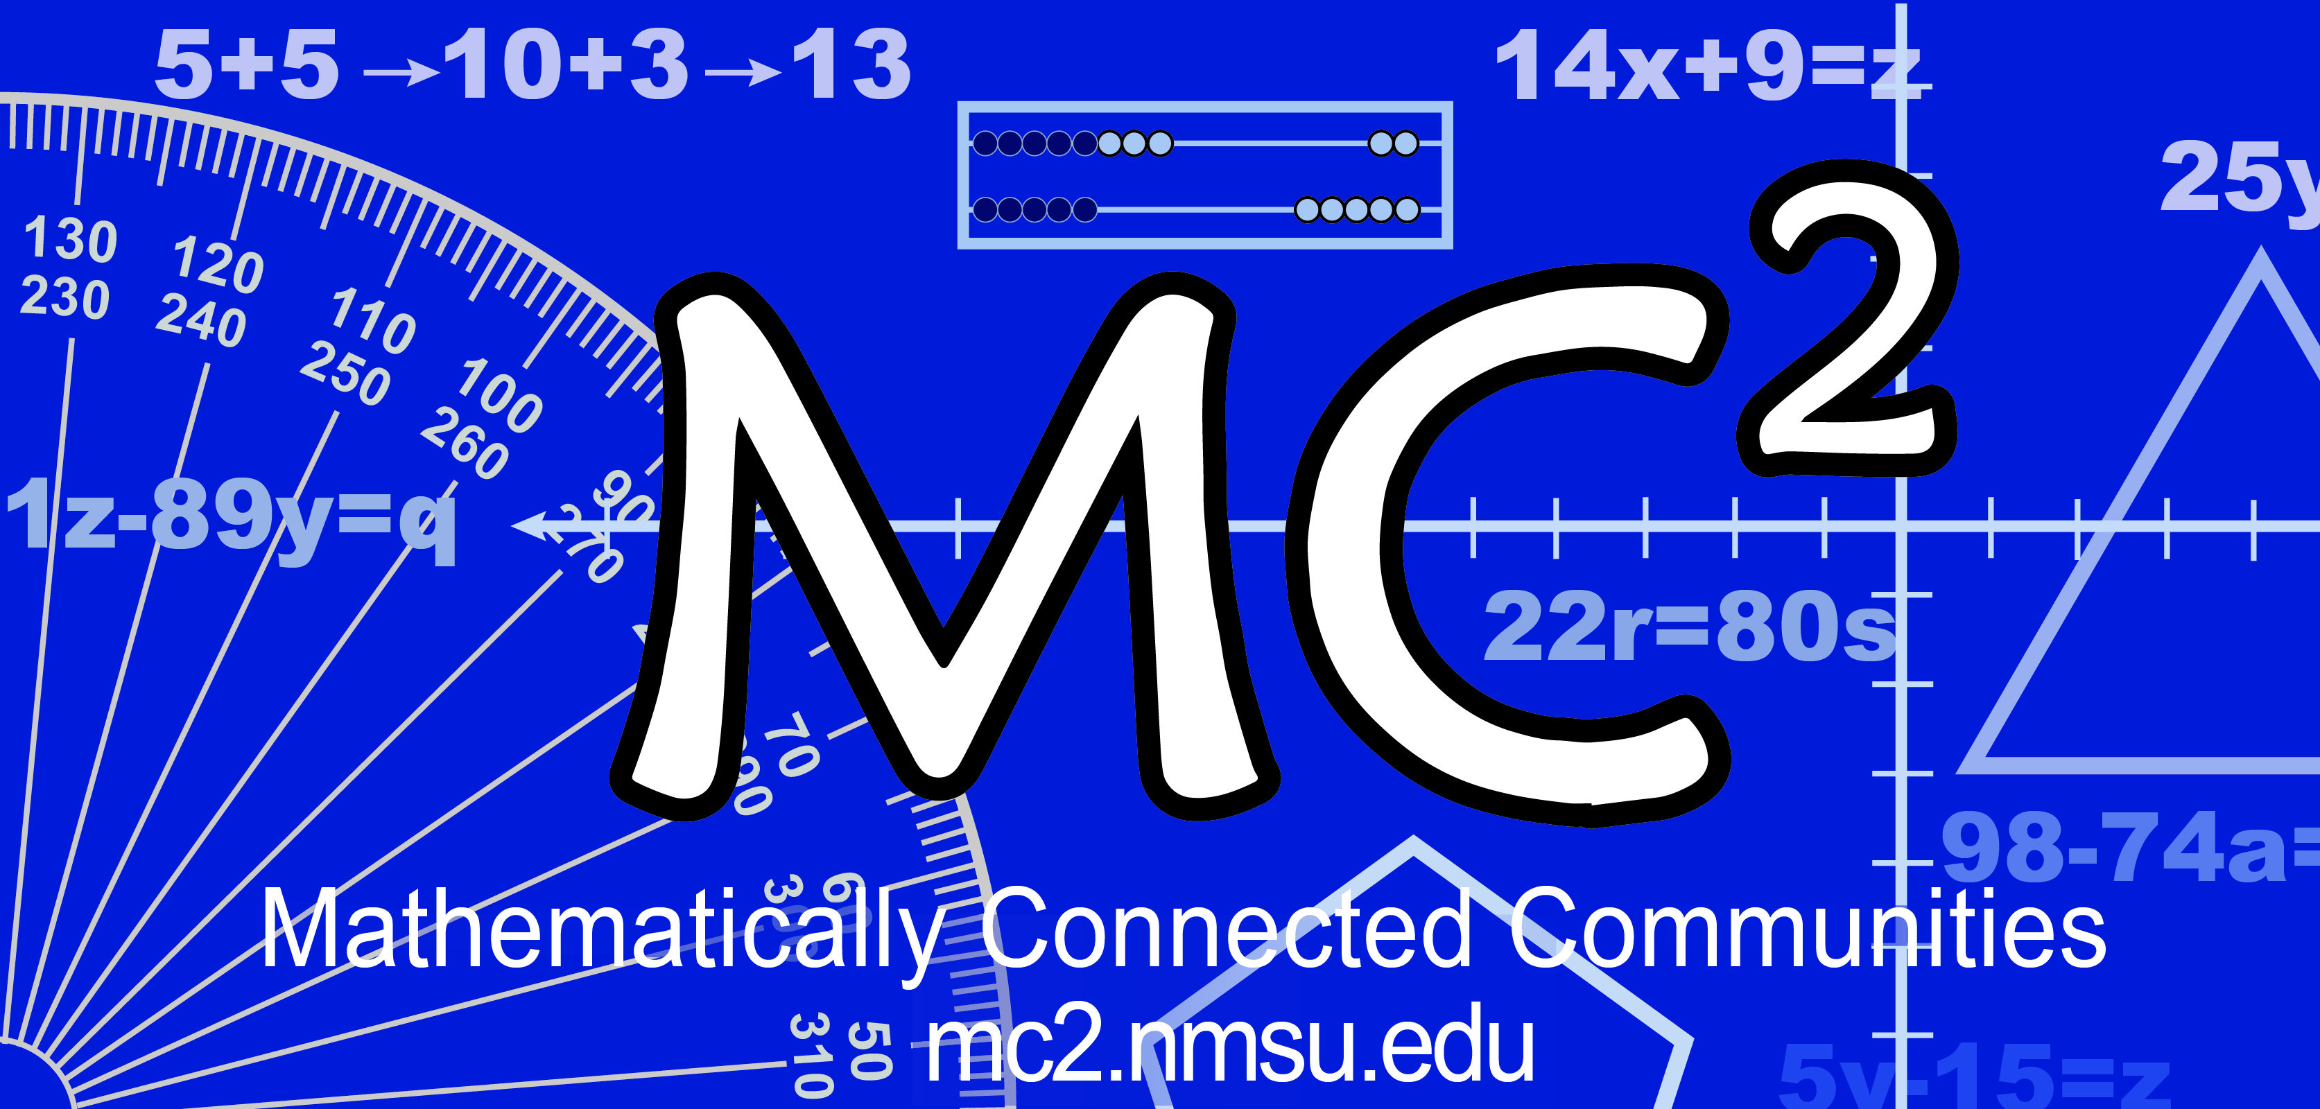
MC² Thinking Protocol
Student Reflection Form

Date: Name: _____________________________________________________________________________

Reflect on the math task and respond to one or more of the following questions.

- What questions do you have about the math?

- What did you struggle with?

- What was your solution strategy? Did it work?

- What might you do different next time?

- Did you add or change your paper after thinking with a partner or the class? If so, what and why?

- What was easy/hard about the problem?

- What was easy/hard when I had to work by yourself?

- What was easy/hard when I had to work together?

- How did the Thinking Protocol support your math understanding?

Note: This form is in WORD so it may be customized to suit your needs by adding, changing, and/or deleting questions.

